# From Legend to Fact: True Stories of Our Family’s History

It may be hard to believe, but our family has been gathering at Lake Stone for family reunions for nearly 70 years. My earliest memory is of attending one of these reunions and wondering how so many people came to be in one place.

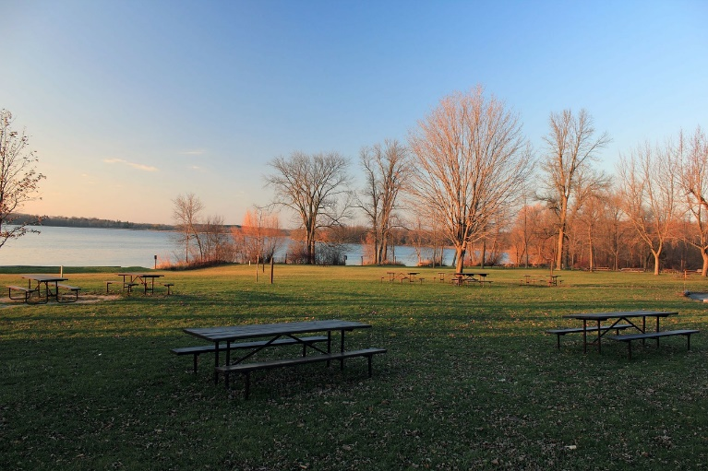

Figure 1. Lake Stone picnic area. Our family has been meeting here for the past 70 years (Gorski, 2016).

What journeys did our parents, grandparents, and great-grandparents embark upon, and how did those journeys lead us here? Our ancestors first arrived in this country more than a century ago.  Not only did they begin forging a rich and unique history of which we can be proud, but they helped to shape the history of the country as a whole.  I've heard many of their stories over the years and even have researched the history surrounding them. I want to share those stories with you and prove that some of the more outlandish tales we’ve heard are actually true!

## Uncle Frank and the Pony Express

For many of our ancestors, the first glimpse of the United States was the Statue of Liberty, which stands in New York Harbor. Some of those ancestors settled in New York, but for others it was merely a temporary stop on the way to new adventures in a new country. For one of our ancestors, Uncle Frank Webner, this meant playing a role in connecting the eastern states with territories on the west coast by riding for the famous Pony Express. Americans living in the mid-1800s and wishing to send mail to California had to choose between sending their communications via a 25-day stagecoach ride or via ship, which could take several months. The Pony Express, begun by William H. Russell, William B. Waddell, and Alexander Majors, offered the innovative and fast option of delivering mail to California in 10 days. Riders rode between stations placed across what is now Missouri, Kansas, Nebraska, Colorado, Wyoming, Utah, Nevada, and California, handing the mail to new riders after 75 to 200 miles. The Pony Express relay system enabled the company to achieve an important milestone in 1861 when riders carried a copy of Abraham Lincoln’s inaugural address from Nebraska to California in one week (Andrews, 2016).

Some of you have heard the stories of Uncle Frank Webner, who was one of the first riders for the Pony Express in the 1860s. Frank would ride from Missouri to California delivering mail in approximately 10 days. He began his career at the age of 14. To us, it may seem amazing to think of a middle school-aged person taking on such a solitary and dangerous job, but, in fact, this was very common. “It wasn’t unusual for teenagers as young as 14 to be hired. One rider named ‘Bronco’ Charlie Miller claimed he was only 11 years old when he first joined the Pony Express” (Andrews, 2016, p. 21). A typical rider for the Pony Express was less than 21 years old and did not have a family (Baker, 2013).

The young men who served the Pony Express never submitted a written application or were interviewed for the job. They simply showed up, shook hands, and were hired on the spot (Andrews, 2016). Often, several members of the same family arrived at the station looking for work; generally, all were hired (Andrews, 2016). Uncle Frank rode up to the station and within 10 minutes he was given his first orders. “During the first year of the Pony Express, riders were brought on at the rate of a hundred hires a week” (Andrews, 2016, p. 27). To reduce the weight carried by the Pony Express horses, the Pony Express management sought slender or undersized riders (D. Jones, 2012).

Uncle Frank’s typical day as a Pony Express rider began before dawn. No matter the station where he had spent the night, an alarm would sound waking all the riders or cowboys, as they sometimes were called. Frank recalled that breakfast was served at long trestle tables and consisted of eggs, bread, and beer! John Andrews (2016), author of *Cowboys, Cactus, and Craziness*, recounts, “Beer was served at every meal because of its long shelf life. The cowboys seemed to enjoy washing down the eggs and toast with the dark brew, some downing as many as two or three mugs of beer before setting out” (p. 33). Immediately following breakfast, the riders rode off heading in opposite directions: one traveled east and the other traveled west. Andrews notes, “Riders exchanged advice or warnings about the trail that they had just covered” (p. 35). The communication system between riders was of key importance, providing information about weather, terrain, and other threats (Andrews, 2016). Baker (2013) tells of the extreme conditions under which the Pony Express riders worked, “sometimes traveling through dust storms, thunderstorms, and snow” (p. 3). Pony Express riders even were subjected to attacks by the Paiute Indian tribe in Nevada during the Paiute War of 1860 (“Pony Express Basic Facts,” 2016). Andrews (2016) states that the riders who served as part of the Pony Express were paid very little for their services. Andrews also mentions that a typical rider rode approximately 75 miles a day before stopping to rest for the night.

We have conflicting information about how long Pony Express riders stayed on the job. “Many riders served for the entire year and a half that the Pony Express was in business” (Baker, 2013, p. 3). Others tell us that the difficult nature of the work contributed to a high dropout rate with many riders only spending a few weeks in employment (“Pony Express Basic Facts,” 2016). Many riders for the Pony Express went on to become government workers (D. Jones, 2012). This was true of Uncle Frank who, after his Pony Express days ended, served as the postmaster general for St. Louis, Missouri. Pony Express riders were a unique group of young men, “unafraid to take on a challenge and willing to push themselves to the limit” (Baker, 2013, p. 2). Baker (2013) believes that there will never again be a team of workers as dedicated as were the men of the Pony Express. We’ve all joked about how Uncle Frank’s stories must be exaggerated, but after doing this research I’ve found that his experiences weren’t atypical.

## Galloping James Clifford, Horse Thief!

As it turns out, Uncle Frank wasn’t our only relative who worked with horses in the Old West. One of our ancestors, Galloping James Clifford, was a horse thief in Hannibal, Missouri in 1888 (“Horse Thief Strikes Again,” 1888). Sadly, this is all we know about him!

## Stefan and Anna Kuchar and the Recipe That Changed the World

While some of our relatives were settling the West, others were arriving in New York and starting businesses. Stefan and Anna Kuchar arrived at Ellis Island in the winter of 1898 (Kuchar, 2000). The story of Anna carrying only a single item off the ship—a small box of cookies—has been passed down through the generations. Those cookies were uniquely suited to travel because they were “hard when dry and chewy when moistened” (Kuchar, 2000, p. 25). The simple cookie provided the young couple with food as well as memories of home during the long voyage. The recipe still lives on in Anna’s Famous Poppy Seed Cookies, available at Magda’s Pastries. Magda’s relatives brought countless other recipes from Poland, adding their traditional baking to the cultural tapestry of their new home (“The Recipe That Changed the World,” 2004). You can still visit the resting place of Stefan and Anna at the family plot near the Bakersfield church.

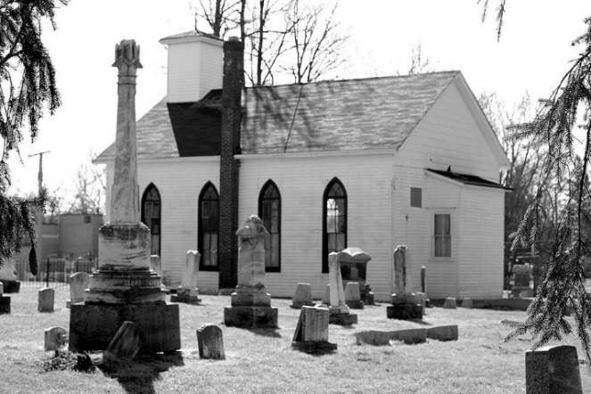

Figure 2. Untitled photograph of the Bakersfield church. This shows Stefan and Anna Kuchar’s final resting place (n.d.).

## Grandpa Walsh, Firefighter!

Grandpa Patrick Walsh spent his days battling the city’s blazes in the 1920s.  He was a noted storyteller and shared many stories about fighting fires using fire engines drawn by a team of horses. (A. Jones, 2014).  The horses were beloved for their fearlessness and dedication. “A fire horse was a dedicated creature, and it was always a sad event in any company when a veteran steed was forced to retire” (West, 2011, p. 131).  Grandpa Walsh worked long hard days with few breaks, but this was typical.  A firefighter in New York City in the 1920s spent nine of 10 days on the job.  Day number 10 was for catching up with family, friends, and neighbors (West, 2011).  Interestingly, I was able to learn what inspired Grandpa Walsh to pursue this career.

The Triangle Shirtwaist Company factory in New York City burned on March 25, 1911, killing 145 workers. It proved to be a turning point in industrial history. After the tragedy, it was revealed that many of the deaths could have been prevented if the company had included basic safety features and practices in its routines, including the presence of multiple ways to exit the building as well as maintenance of firefighting equipment.  The physical design of the factory also contributed to the loss of life in this fire.  The fire raised a number of questions about factory conditions (Marlowe, 1911). Patrick, still a young boy at the time, witnessed the devastation firsthand. Later, he would write about the experience in his journal, describing how it inspired him to become a firefighter.

However, Grandpa Walsh’s life in New York wasn’t always filled with daring; there was also fun to be had. We may take leisure time for granted now, but at the turn of the 20th Century, it was still a relatively new idea. Progressive labor laws and an increased attention to worker well-being meant that people were beginning to have more free time than they did during previous generations (Scott & Brown, 2011). For our family, this meant trips to one of the most popular attractions of the day. Hard-working New Yorkers in the 1930s made frequent trips to Coney Island to enjoy a day at the beach (Cox, 1979).

Grandpa Walsh told stories of bringing my mother and her brothers on weekend excursions to Coney Island in the 1930s. They escaped the oppressive August heat of Brooklyn for a chance to enjoy the surf as well as to ride the roller coaster and other attractions (P. Walsh, personal communication, December 25, 1972). Historian Richard Cox (1979) tells us, “After the 1920s, when trolleys and trains linked Coney Island to the rest of the city, a vast cross-section of New Yorkers gained access to its beaches, its rides, and its hoopla. By 1920, Coney Island had become a weekly destination for millions of city dwellers” (p.137). As New York City continued to grow and become more crowded, many of our relatives moved and put down roots elsewhere. The post-war industrial boom made family cars and homes more affordable, and relocating to different parts of the country was easier than ever (C. Klein & L. Klein, 2002).

## Gr**eat Aunt Lucy and the Civil Rights Movement**

We all know that Great Aunt Lucy lived her entire life in Washington, DC, our nation’s capital. However, did you know that she participated in the March on Washington in 1963 where she saw and heard Martin Luther King, Jr., speak? On August 28, 1963, more than 250,000 people flooded Washington, DC to march in support of the Civil Rights Movement. Marchers traveled to the capital by all manner of transportation—some journeyed hundreds of miles from cities such as Milwaukee and St. Louis (Porter, n.d.). Aunt Lucy joined with marchers, who had gathered from across the country, to demand equal rights for African Americans. The march had many goals, but some of the main ones were to compel the government to pass meaningful civil rights legislation, eliminate the segregation of schools, and prohibit racial discrimination in hiring (Jackson, Munroe, & Cunniff, 2015). The demonstration concluded with Martin Luther King, Jr., delivering his famous “I Have a Dream” speech and is credited with helping to propel the Civil Rights Act into law a year later (Johnson et al., 2008).

## Uncle Hiram, Naturalist and Ant Remover!

While some of our family was drawn to the excitement of city life, others chose more serene locations to settle. Most of you have had the pleasure of visiting Uncle Hiram’s cottage; however, what you may not know is that Hiram not only built that house himself but also helped to create many of the local hiking trails and to organize conservation efforts. In fact, Hiram used his knowledge of the local environment to contribute to some of the *Audubon Field Guides*—a very popular series of nature books that have sold more than 18 million copies (North American Publishers’ Union [NAPU], 2014).

Our uncle’s knowledge of animals and nature has come in handy on many occasions. Many of you remember when I asked Uncle Hiram for help to control an invasion of ants at our lake house. Hiram told me to purchase a package of thick sidewalk chalk and meet him at the lake. When we got there, he took the chalk and drew several heavy lines across the bottom of the driveway. As I watched, I saw ants divert from their path and head away from the house. They would not cross that chalk line.

Uncle Hiram was right! Ants can be controlled by drawing a chalk line! As Edgar Smith (2012) explains in his book, *Pesky Pests*, “When ants are on the move, they create a pheromone trail for other ants to follow. Drawing the chalk line breaks up the pheromones, dispersing the army of ants from their march” (p. 21). Uncle Hiram watched ants engage in this behavior but never knew what caused it. Uncle Hiram proved for me that there is a high level of accuracy in old family tricks that have been passed down from one generation to the next. Individuals may not always be aware of “why” things work, but they certainly understand “how” things work.

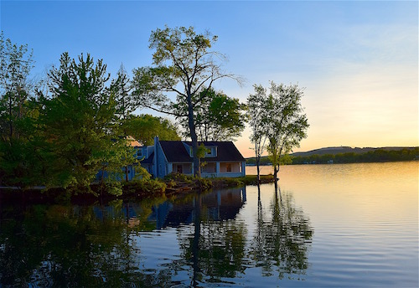

Figure 3.  Lake house at sunset.  This photograph shows the author's house at the time of the ant invasion (2013).

## Aunt Miranda’s Fight to Save South Florida’s Eco-system

Uncle Hiram isn’t the only member of our family who was passionate about conservation; Aunt Miranda has raised awareness about the impact of non-native species on the Florida eco-system. When a non-native plant species is introduced to a welcoming and supportive climate like that of South Florida, the species shows its ability to thrive and spread aggressively outside its native range. A naturally aggressive plant may be especially invasive when it is introduced to a habitat that supports growth (Petersen, 2015). Think about a plant that struggles to survive the harsh New England winters. Now imagine that plant transported to Florida and offered abundant sunshine, plentiful rain, and nutrient-rich soil. The plant will “explosively take over and dominate the habitat into which it is introduced” (Ricci, 2013, p. 44).

Aunt Miranda knew well the dangers that simple transplanting could bring, and she spread the word, speaking at town meetings, writing letters to the editor, and spearheading a campaign to inform new buyers of the importance of cultivating native species. Local horticulturist Ellen Rivas (2016) claims, “The introduction of non-native species represents the greatest threat faced by the flora and fauna of Florida" (para. 3). Rivas, a native of southwest Florida, explains:

The introduction of non-native species to the welcoming biome represented in southwest Florida poses a real danger to native flora and fauna. When a transplanted species is placed in its new environment, growth may go unchecked in the absence of insect enemies or meteorological factors that previously kept the growth of the species in balance. (para. 4)

As you can see, our family history is filled with a variety of colorful characters—with each one shaping the time and place in which he or she lived. Those ancestors never shied away from new challenges or adventures. They have given us a legacy that we can be proud of and that we can aspire to build on for the future generations of our family. I hope that learning more about the history of our family not only has shown you who we are and where we came from, but has offered you an idea of the shape our future could to take.

References

Andrews, J. (2016). Cowboys, cactus, and craziness. San Francisco, CA: West Bay Press.

Baker, P. (2013, November). History of the Pony Express. US News, 11(1), 1-5. Retrieved from http://www.usnews.com/opinion/articles/2013/11/04/history-of-pony-express

Cox, R. (1979). *Coney Island: The amusement park as urban symbol in American art*. New York, NY: Brooklyn College Press.

Gorski, T. (2016). *Lake Stone picnic area* [Photograph]. Retrieved from https://www.gorksiblogspot.com

Horse thief strikes again. (1888, July 1)

Jackson, D., Munroe, J., & Cunniff, J. (2015). The march that changed our lives. *Journal of Our Times, 12*(1). Retrieved from http://www.jot.com/ae2f1d271

Johnson, K., Lewis, M., Green, J., Walker, C., Hill, W., Colman, D., . . . Davis, R., (2008). Civil rights and the American dream*. Journal of Our Times, 2*(4).Retrieved from http://www.jot.com/ac5b4f712hc4

Jones, A. [youtubeman]. (2014, September 12). *Up in smoke* [Video file]. Retrieved from https://www.youtube.com/12345

Jones, D. (2012). A history of the Pony Express. Boston, MA: Boston Books.

Klein, C., & Klein, L. (2002). Working conditions and the American middle class. *Exploring Society* (pp. 94 – 96). Retrieved from http://www.exploringsociety.com/20021003

Kuchar, M. (2000). *Kuchars, kitchens, and kuchen*. New York, NY: Skyscraper Publishing.

Lake house at sunset [Photograph]*.* (2013). Retrieved from https://www.gorksiblogspot.com

Marlowe, G. (1911, March 26). Deadly fire draws attention to factory conditions. *The Brooklyn Banner.* Retrieved from http://brooklynbanner.com/archives/2011/03/26/shirtwaistfire

North American Publishers’ Union. (2014). *Top sellers of our times.* Retrieved from http://www.napu.org/topsellers/3219203

Petersen, B. (2015, May). Enemies among us. *Florida Nature Magazine, 5*(6), 35-36.

Pony Express basic facts. (2016). Retrieved from   
http://www.ponyexpressproject.org/learn-more/

Porter, B. (n.d.). *1963 March on Washington for jobs and freedom* [Blog post]. Retrieved from http://www.historyblog.org./1963marchonwashington

The recipe that changed the world. (2004). American Journal of Cooking, 13(1). Retrieved from http://www.americanjournalofcooking.com

Ricci, S. (2014, August). The migration of plants. *Plants Facts* (pp. 43 – 46). Retrieved from http://www.plantsfacts.com/migration

Rivas, E. (2016). *Florida fauna and flora: The future is bleak*. Retrieved from http://www.southfloridagardens.org

Scott, B., & Brown, Q. (2011). The origin of leisure time. *Journal of Sociology*, *4*(1), 94-96. Retrieved from http://www.journalofsociology.com/20110401

Smith, E. (2012). *Pesky pets*. St. Louis, MO: Arches Press.

[Untitled photograph of the Bakersfield church]. (n.d.). Retrieved from https://www.gorskiblogspot.com

West, K. (2011). Unsung heroes. Journal of Firefighting, 12(1), 130-142.   
doi:10.1234/5678-9123.4.5.6